OMFS Survival Guide – MRCS

Vascular Anatomy

* Posterior abdominal wall
  + Bones
    - Lumbar vertebrae
    - Sacrum
    - Wings of ilium
  + Muscles
    - Diaphragm
    - Quadratus lumborum
    - Psoas major
      * Arises from transverse processes of lumbar vertebrae and inserts onto lesser trochanter of femur
      * Femoral artery lies of psoas major tendon
      * With iliacus, flexes hip
      * Enclosed in psoas sheath – collections can occur here (psoas abscess)
    - Iliacus
  + Retroperitoneal organs
    - Pancreas, kidneys, ureters, suprarenals, aorta, IVC, para-aortic nodes, lumbar sympathetic chain
  + Suprarenal glands
    - Lie against crura of diaphragm
    - Left related to stomach and lesser sac, right lies behind right lobe of liver and behind IVC
    - Blood supply
      * Branch from aorta
      * Branch from phrenic artery
      * Branch from renal artery
      * Venous: right to IVC, left to renal vein (right adrenal vein most easily damaged!)
    - Structure
      * Cortex
        + From mesoderm
        + Adrenocortical hormones
      * Medulla
        + From neuroectoderm
        + Adrenaline and noradrenaline
  + Abdominal Aorta
    - Enters abdomen via aortic hiatus (T12) and ends at L4 (bifurcation)
    - Lies against vertebral bodies
    - Early aneurysm = 4cm; if 5cm< ?surgery
    - Anteriorly
      * Pancreas
      * Third part of duodenum
      * Small intestine
      * Crossed by LEFT renal vein (which is longer vein than right)
    - Branches
      * Unpaired
        + Coeliac – giving of left gastric, hepatic and splenic arteries
        + Superior mesenteric
        + Inferior mesenteric
      * Paired to viscera
        + Suprarenal
        + Renal
        + Gonadal
      * Paired to parietes
        + Inferior phrenic
        + Lumbar
      * Terminal branches
        + Common iliacs – to internal and external (in front of sacroiliac joint, crossed at bifurcation by ureter)

External iliac

Runs medial to psoas major

Forms femoral artery but gives off inferior epigastric branch and deep circumflex iliac before becoming femoral

Internal iliac

Passes into pelvis between ureter and internal iliac vein

Anterior and posterior branches

Iliolumbar

Lateral sacral

Obturator

Superior gluteal

Inferior gluteal

Internal pudendal

Superior vesical

Inferior vesical

Middle rectal

Uterine (in females)

* + - * + Median sacral
  + Inferior Vena Cava
    - Commences at L5 behind right common iliac artery *(usually vein superficial to corresponding artery)*
    - Lies to right of aorta
    - Passes through diaphragm at T8 and drains into right atrium
    - Related to small bowel, third part of duodenum, head of pancreas, first part of duodenum
    - Passes behind epiploic foramen
      * Foramen separates IVC and portal triad (hepatic artery, portal vein, common bile duct)
    - Receives right and left hepatic veins
  + Lumbar sympathetic chain
    - Continuation of thoracic
    - Lies of lumbar vertebrae and lumbar arteries lie deep to it, veins are superficial so can be damaged in sympathectomy
    - Ganglia send grey rami to lumbar spinal nerves
    - Branches pass to plexuses surrounding aorta
    - Parasympathetic to pelvis = anterior rami of S2,3,4

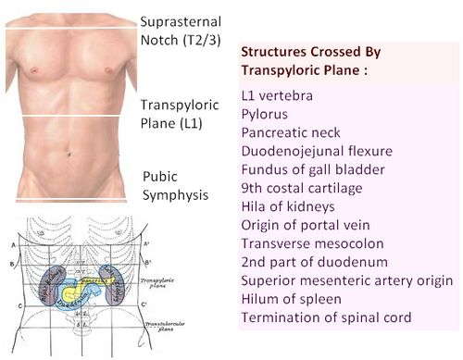

* Arteries of the upper limb
  + Axillary
    - Starts at lateral border of first rib
    - Continuation of subclavian
    - Ends at lower border of axilla (lower border of teres major)
    - Becomes brachial artery
    - Divided into 3 by pectoralis minor
      * 1st 
        + Superior thoracic artery
      * 2nd
        + Acromiothoracic trunk
        + Lateral thoracic artery
      * 3rd
        + Subscapular artery
        + Anterior circumflex humeral
        + Posterior circumflex humeral
    - Covered by pectoralis major
    - Brachial plexus lies above and behind artery initially but then cords take positions around artery according to names (ie lateral, medial, posterior)
  + Brachial
    - Ends at neck of radius to divide into radial and ulnar arteries
    - Superficial
    - Median nerve lies lateral then anterior then medial to artery
    - Branches
      * Profunda (accompanies radial nerve)
      * Superior ulnar collateral (accompanies ulnar nerve)
      * Nutrient (to the humerus)
      * Inferior ulnar collateral
  + Radial
    - Commences at level of radial neck
    - Lies on tendon of biceps muscle
    - Upper half overlapped by brachioradialis
    - In forearm, lies between brachioradialis and flexor carpi radialis (palpated in wrist between these 2)
    - Radial nerve lies along lateral side of artery
    - Distal to pulse, gives off branch to superficial palmar arch
    - Passes deep to APL tendons and EPB to enter anatomical snuffbox
    - Pierces first dorsal interosseous muscle and adductor pollicis and forms deep palmar arch with deep ulnar artery
  + Ulnar
    - Largest of terminal branches of brachial artery
    - Lies on FDP and overlapped by FCU
    - Median nerve crosses superficially to ulnar artery – separated by deep head of pronator teres
    - In forearm, artery becomes superficial between FCU and FDS then crosses flexor retinaculum to form superficial palmar arch with radial artery
    - Ulnar nerve is on medial side of artery
* Arteries of lower limb
  + Femoral
    - Continuation of external iliac
    - Passes through femoral canal and adductor canal
    - Terminates after passing through hiatus in adductor magnus
    - Becomes popliteal artery
    - Accompanied by femoral vein
    - Branches
      * Superficial circumflex iliac – encountered in inguinal hernia repair
      * Superficial epigastric
      * Superficial external pudendal
      * Deep external pudendal
      * Profunda femoris – arises distal to inguinal ligament
        + Femoral above this is called common femoral and below it called superficial femoral
        + Passes deep to adductor longus and gives of medial and lateral circumflex branches and 4 perforating branches

Anastomoses between hip and knee and supply muscles

Damage to medial circumflex causes avascular necrosis

* + Popliteal
    - Continuation of femoral artery at adductor hiatus and terminates at lower popliteus muscle
    - Deep in popliteal fossa
      * Tibial nerve 🡪 pop vein 🡪 pop artery
    - Branches
      * Muscular
      * Geniculate (to knee)
      * Terminal – anterior and posterior tibial arteries
  + Posterior tibial
    - Larger of 2 branches
    - Deep to soleus and becomes superficial in lower third of leg
    - Passes behind medial malleolus between FDL and FHL tendons, with tibial nerve
      * TOM DICK AND NOT HARRY
        + Tibialis posterior
        + FDL
        + Posterior tibial artery
        + Tibial nerve
        + FHL
    - Divides into medial and lateral plantar arteries
    - Gives off fibular artery
      * Runs down posterior fibula
  + Anterior tibial
    - Runs underneath popliteus and descends into anterior compartment of leg
    - Becomes superficial near ankle between EHL and TA tendons
    - Continues as dorsalis pedis
      * Joins lateral plantar artery to form plantar arch
* Veins of lower limb
  + Deep
    - Accompany major arteries
      * Femoral vein lies medial to femoral artery in triangle
  + Superficial
    - Long saphenous - MEDIAL
      * Runs over medial malleolus and then ascends over medial condyles of tibia and femur to groin
      * Pierces deep fascia to enter femoral vein
      * At groin, tributaries from lower abdominal wall join long saphenous vein
        + Superficial epigastric – dilates in IVC obstruction
        + Superificial circumflex iliac
        + Superificial external pudendal
      * Communicates to deep venous system by perforating branches
    - Short saphenous - LATERAL
      * Commences behind lateral malleolus
      * Courses over back of calf and perforates deep fascia near popliteal fossa and terminates in popliteal vein
      * Accompanied by sural nerve (sensory branch of tibial nerve)

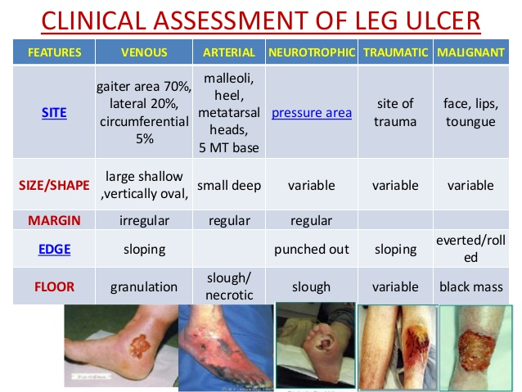

Vascular Surgery Key Revision Points

* DIC – raised fibrinogen degradation products and low platelets, raised APTT
  + Give FFP, cryoprecipitate and platelets
* Gangrene – necrosis and decay of body tissue
  + Reduced blood supply secondary to vascular disease
  + Clostridium perfringens – linked to gas gangrene; produces crepitus and septicaemia
  + Wet gangrene = both arteries and veins affected causing obstruction of both
    - Treat via abx and debridement
  + Due to infection of tissues that causes inflammation that blocks blood supply
  + Dry gangrene = just arterial obstruction
    - Treat via restoring blood supply
* Joint haemarthroses = haemophilia (factor 8 or 9 deficiency)
* Vit K dependant clotting factors
  + 2 (prothrombin), 7, 9, 10
* Start on IV heparin pre-op as has shorter half life so can stop before surgery
* Pseudo-aneurysms
  + Common in femoral artery
  + Collection of blood between muscularis and adventitia layers of artery resulting from trauma to artery
  + Common in IVDU
  + Contain less wall layers than true aneurysms
* Protein C
  + Inactivate active forms of factor 5a and 8a
* Pulmonary embolism
  + If severe, can get cyanosis, hypotension, raised JVP
* 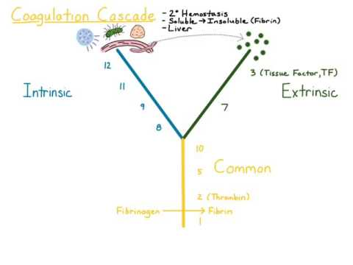
  + Factor 13 cross links fibrin
  + Intrinsic pathway = 11, 9, 10
    - APTT
  + Extrinsic = 7
* Warfarin impairs vitamin K recycling for reduce vit K dependant clotting factors
* Having one aneurysm increases risk of having another one elsewhere
* Aneurysms
  + Occur opposite disease affected areas of arteries
  + False = blood between muscularis and adventitia
    - Mycotic aneurysms are false aneurysms – linked to endocarditis
  + Dissecting = tear in intima which moves along vessel
  + Repair
    - Open
    - EVAR
      * Requires long term follow up with CT/USS – risk of endovascular leak!!!
      * Stent graft insertion through femoral artery
        + Can be used in supra and juxta renal but not in all infrarenal
* PE
  + Commonest symptom is SOB
  + Pain only happens if pulmonary infarction occurs
* Factor 5 Leiden (thrombophilia) increases risk of DVT so screen for if recurrent DVTs
* VWD – platelet dysfunction and abnormal factor 8
  + Give desmopressin and factor 8
* Venography is gold standard for DVT but USS more commonly done as is less invasive
* Fat embolism = petechial rash on trunk and conjunctiva, tachycardia, hyperthermia, retinal haemorrhages
* High transferrin = iron deficiency anaemia
  + Anisocytosis and poikilocytosis on blood film
* High ferritin - ?thalassemia
* All donated blood screened for hep B, hep C, HIV, treponema pallidum antibody
* History of DVT can increase risk of varicose veins as can damage valves and cause back-flow
* Factor 7 combines with tissue factor to activate factors 9 and 10 – EXTRINSIC
* Leg ulcers
  + Arterial – dorsum, painful (especially at night), low ABPI
  + Neuropathic – deep, painless, punched out, sole of foot
  + Venous – affect gaiter area (medial malleolus), linked to venous changes/DVT
* Aortic dissection – pulsus paradoxus
  + Can progress to cause cardiac tamponade!!
    - Requires percardiocentesis or surgery if unstable
  + Types
    - A – ascending or ascending plus descending – requires surgery (aortic root replacement)
    - B – descending only – manage medically (antihypertensives)
  + Type B can be managed medically, type A require open repair/EVAR via LEFT THORACOTOMY
* EPO produced by peritubular fibroblasts of renal cortex in response to hypoxia
* Anticoagulants
  + Heparin – antithrombin 3
  + Aspirin – thromboxane A2
  + Warfarin – vitamin K dependant factors
  + LMWH – factor 10a
* Rhesus – mother with Rh negative blood is exposed to Rh positive blood from fetus
  + In next pregnancy, mother will produce anti-Rh antibodies against foetus
* Anti-thrombin 3 deficiency predisposes to clotting
* vWD – mild bleeding ie epistaxis
* Haemophilia – spontaneous haemorrhage – ie joint haemarthrosis
* Acute haemorrhage causes macrocyctic picture
* Air embolism
  + Death caused by air being trapped in right ventricular outflow tract
  + Can be caused by open heart surgery
* MI can cause embolism causing acute limb ischaemia
* Complications of venous surgery
  + Skin discolouration
  + DVT
  + Skin ulceration
* Duplex scan prior to SPJ surgery as location is variable
  + Usually 1-4cm lateral and inferior to pubic tubercle
* Bleeding time assesses platelet function
  + Normal in haemophilia
* Anaemia reduces oxygen carrying capacity in the blood
* Thrombosis – occlusion that has filled full artery and caused blockage – ie not intermittent claudication
* Vit b12 involved in maturation of red blood cells
* Popliteal aneurysms
  + Most common form of peripheral aneurysm
  + Repaired if symptomatic/asymptomatic with thrombus
* Gallop rhythm = PE
* Thoracic outlet syndrome
  + Neurological symptoms most common
  + Can be treated non-operatively (rest, analgesia, physio) or with surgery if severe dysfunction
* Macrocytic anaemia – hyper-segmented neutrophils
* AAA repair
  + Can cause ischaemic colitis, trash foot, incisional hernia and paraplegia
    - Paraplegia caused by damaging artery of Adamkiewicz which comes off aorta and supplies spinal cord from T8
* Aortic dissection can cause MI by affecting coronary arteries and cardiac tamponade
* Massive transfusion = loss > 50% over 3hours
* Mesenteric vessel disease
  + Acute embolus – sudden onset pain, rapid deterioration
  + Acute on chronic ischaemia – longer prodrome; post-prandial abdominal pain
  + DO CT ANGIOGRAPHY IN ANY ARTERIAL OR VENOUS MESENTERIC DISEASE
    - If poor renal function, do duplex scan of abdomen
  + If peritonism, do laparotomy
  + Mesenteric vein thrombosis = give IV heparin
* Venous ulcers sign of superficial venous insufficiency
* Always try medical/conservative treatment of PAD prior to surgery
  + Angioplasty if lesion is short and good distal vessel runoff
  + Surgery if angioplasty failed or unsuitable
* Amputations
  + If dead (non-viable), deadly (posing threat to life), dead useless (viable but prosthesis preferable)
  + In ortho, last resort or if chronic fracture non-union
  + In vascular, diabetic foot sepsis or embolic event
  + Types
    - Pelvic disarticulation (hindquarter)
    - Above knee – quick, functional outcome not great, use equal anterior-posterior flaps, used in those with fixed flexion deformity
    - Gritti stokes (through knee) – patellar conserved, femoral condyles removed
    - Below knee (using Skew or Burgess flaps) – heals less reliably, functional outcome good
    - Symes amputation (through ankle)
    - Mid foot/digits
  + Level of amputation depends on disease, desired outcome, co-morbidities
* Marjolins ulcer – squamous cell carcinoma occuring at sites of chronic inflammation or previous injury (ie previous ulcers)
  + Heaped/raised borders
* Emboli occur secondary to AF
* Cervical rib – C7
  + Adsons test – symptoms worse when hand overhead
* Short saphenous vein close to sural nerve
* SPJ surgery MUST be imaged with duplex scan prior to surgery
* Treatment of chronic venous insufficiency:
  + If cosmetic/lipodermatosclerosis/thrombophlebitis/bleeding
  + Uncomplicated varicose veins – endothermal ablation (first line first time), foam sclerotherapy (seconda line), SF/P disconnection, compression stockings, surgery if failed ablation previously!!
  + Chronic venous insufficiency – class 2 or 3 compression stockings
  + SF reflux – injection sclerotherapy or SF ligation (Trendelenburg procedure)
* Venous duplex scan assesses axillary vein thrombosis (arm pain and swelling, and dusky fingers)
  + Give catheter directed TPA
* Give 3000 units heparin in vascular theatre prior to cross clamping
* Iliac disease makes EVAR repair of abdominal aorta complicated so do open surgery if patient fit
* Aneurysms
  + CT if greater than 5cm
  + Operate on if greater than 5.5cm
  + Surgical repair
    - Laparotomy if rupture (CT if stable beforehand)
    - EVAR if aneurysm has long neck, straight iliac vessels, health groin vessels
      * Fenestrated grafts for supra-renal
      * Can cause endoleaks
      * Requires follow up
* Acute limb ischaemia
  + Thrombus occluding artery
    - Do embolectomy or heparinisation (embolectomy if isolated lesion)
  + Appearance
    - White - < 6 hours 🡪 embolectomy
    - Mottled and dusky - 6-12 hours 🡪 angiography
      * Need fasciotomy if time to theatre > 6 hours
    - > 12 hrs – fixed mottling 🡪 amputation
* In arterial surgery, use vein as graft unless varicose veins, then use PTFE graft with vein cuff
* Bilateral occluded common iliacs; do aorto-bifemoral bypass if younger (axillo-bifemoral if older as have worse functional outcome)
* Charcot foot = neuropathy (diabetes)
* Adductor canal compression – young males, claudication and weak pulses peripherally
  + Compression of femoral artery by tendinous band of adductor magnus
* Pentoxifylline cn be used to improve ulcer healing rates but don’t give regular antibiotics as leads to resistance