OMFS Survival Guide – MRCS

Abdomen and Pelvis

Surface Anatomy

* Inguinal ligament (pouparts) – from ASIS to pubic tubercle
* Vertebral levels
  + T9 = xiphoid
  + L1 = transpyloric plane
    - Halfway between sternum and pubis
    - Pylorus, pancreatic neck, duodenojejunal flexure, fundus of gallbladder, 9th costal cartilage, hila of kidneys, termination of spinal cord
  + L3 = subcostal plane
    - 10th rib, origin of IMA
  + L4 = supracristal plane
    - Bifurcation of aorta
    - Umbilicus lies between L3/L4
* Viscera
  + Spleen underlies 9-11th ribs

Abdominal fascia and muscles

* Superficial fatty layer (camper)
  + Continuous with superficial fat
* Deeper fibrous layer (scarpa)
  + Becomes colles fascia
  + Attached to perineal bodyand to rami of pubis and ischium
    - Rupture of urethral bulb causes extravasation to scrotum but ever down to limb
* Nerve supply = T7-L1
* Muscles
  + Rectus abdominis
    - Pierced by superior epigastric vessels
    - Sits is rectal sheath
      * Above line – superior epigastric vessels from internal thoracic
        + Anterior = external oblique and anterior portion of internal
        + Posterior = poster part of internal and transversus abdominis
      * Below line – inferior epigastric vessels from external iliac
        + Anterior = all three muscles
        + Posterior = nothing (just transversalis fascia)
  + Neurovascular bundles run between 2nd and 3rd layers of muscles

Abdominal Incisions

* Midline – through linea alba; bloodless
* Paramedian – rectus protects peritoneal scar
* Subcostal (kocher) – biliary/spleen
* Gridiron – appendix; mcburneys point (2/3s laterally along line from umbilicus to ASIS); muscles incised in line with fibres
* Pfannenstiel – gynae; csection;

Inguinal Canal

* Testes and cord pass through it (round ligament in females)
* Between deep and superficial ring and lies parallel to inguinal ligament
* Relations
  + Anteriorly – skin, superficial fascia, external oblique aponeurosis (internal oblique lateral 1/3)
  + Posteriorly – conjoint tendon medially and transversalis fascia laterally
    - Conjoint tendon = internal oblique + transversus abdominis
  + Above = internal oblique and transversus abdominus
  + Below = inguinal ligament
* Contents
  + Spermatic cord (males)
    - Fascia – external spermatic, cremasteric, internal spermatic
    - Arteries – testicular (aorta), cremasteric (inferior epigastric), vas (inferior vesical)
    - Veins – pempniform plexus, cremasteric, vas
    - Nerves – nerve to cremasteric, sympathetics T10-T11, ilioinguinal (not directly in cord)
    - Vas
    - Lymph
    - Patent processus vaginalis (indirect inguinal hernia!)

Peritoneal Cavity

* Closed in males but perforated by openings of uterine tubes in females

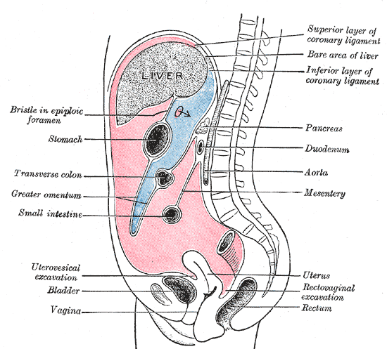

* Mesenteries, omenta and mesocolon all carry vascular supply to contained viscera
* Pringles manoeuvre – used if cystic artery torn 🡪 compress hepatic artery

GI Tract

* Stomach
  + Body = parietal cells (secrete HCL)
  + Antrum = secretes gastrin 🡪 alkaline secretions
  + Lesser omentum attaches to lesser curve
  + Blood supply
    - Gastric arteries (left from coeliac, right from hepatic)
    - Gastro-epiploic (right from hepatic, left from splenic)
    - Short gastric (from splenic)
    - Veins drain to PORTAL system
  + Lymph follows arterial supply
  + Vagal supply
    - Via oesophageal hiatus
    - Motor and secretory supply
    - If injured, surgery requires drainage procedure
    - Highly selective vagotomy spares nerve of Latarjet
  + Posterior gastric ulcer can eorde splenic artery
* Duodenum
  + Becomes retroperitoneal (2nd and 4th parts)
  + 1st – overlapped by liver; posterior to it lie portal vein, CBD, gastroduodenal artery
  + 2nd – curves around head of pancreas; lies on right kidney; crossed by transverse colon; opening of CBD and accessory pancreatic duct
  + 3rd – crosses IVC, aorta and L3; crossed by SMA
  + 4th – ligament of trietz = from right crus of diaphragm to termination of duodenum
* Small intestine
  + Mesentery contains SM vessels and autonomic nerve fibres
  + Jejunum has thicker wall, larger valvular conniventes, lesser arcades
* Appendix – 75% retrocaecal
* Rectum
  + Upper 2/3s anteriorly covered by peritoneum
  + Denonvillers separate rectum with anterior structures
  + Anal canal
    - Upper half = columnar – adenocarcinoma
    - Lower half = squamous – SCC
    - Blood supply – anastomosis between 2 venous systems
      * Upper – superior rectal artery (IMA)
      * Inferior – inferior rectal vessels (internal pudendal – internal iliac)
* Liver
  + Ligamentum teres = remnants of left umbilical vein
  + Ligamentum venosum = remnant of ductus venosus

Transpyloric Plane of Addison:

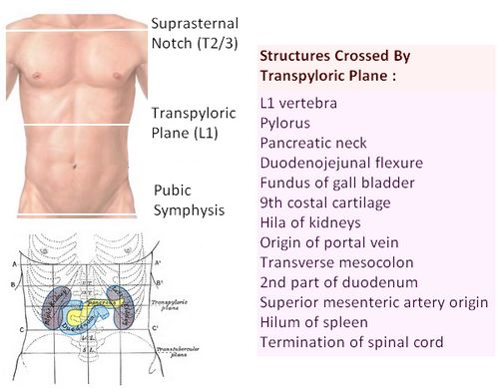

The transpyloric plane is an important landmark. It lies halfway between the suprasternal notch and the symphysis pubis at the level of L1. It coincides with the following.

The other landmarks of the abdomen which separate the abdomen into 9 regions are the intertubercular plane which connects the tubercles of the iliac crests (5cm posterior to the ASIS) and passes through the upper border of L5; and the vertical planes which are the midpoint of clavicle to a point midway between the ASIS and the pubic symphysis.

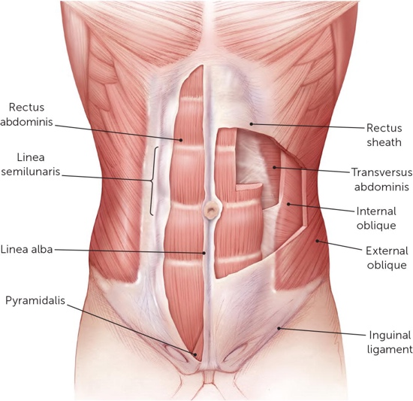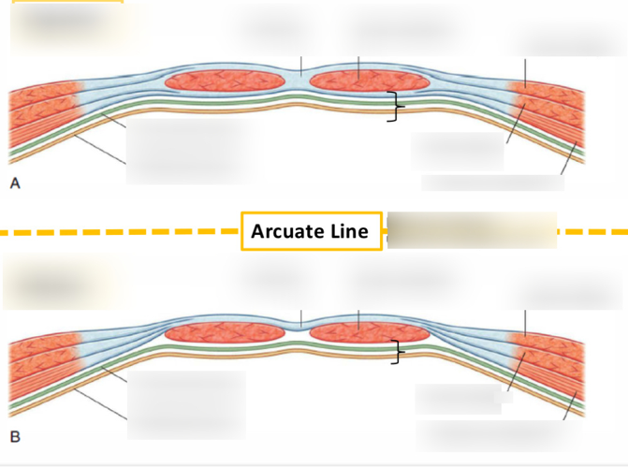Anterior Abdominal Wall:

Layers of the anterior abdominal wall: skin, camper’s fascia (superficial fatty layer) , scarpas fascia , muscles (depending on the incision), transversalis fascia, extraperitoneal fat, peritoneum

Rectus abdominis and its pair join at the linea alba in the midline to form a wide strap that runs longitudinally down the anterior abdominal wall. The rectus abdominis lies within the rectus sheath which is formed by the aponeuroses of the 3 muscles.

Arcuate line – midway between the umbilicus and pubic crest. It demarcates the lower limit of the posterior rectus sheath.

Any incision over the rectus abdominis will go through the anterior rectus sheath.

Anterior rectus sheath from the costal margin to the arcuate line is formed by the external oblique aponeurosis and the anterior leaf of the split internal oblique aponeurosis. The posterior rectus sheath is formed by the posterior leaf of the internal oblique aponeurosis and the transversus abdominis aponeurosis.

Anterior rectus sheath below the arcuate line is made up of the posterior rectus sheath and the external oblique and internal oblique aponeurosis. No posterior rectus sheath below the arcuate line. The rectus abdomins lies directly on the transversalis fascia.

Above the umbilicus there is a single sheet of fascia – below the umbilicus the fascia is divided into 2 layers the campers and scarpa’s fascia.

Epiploic Foramen (of Winslow):

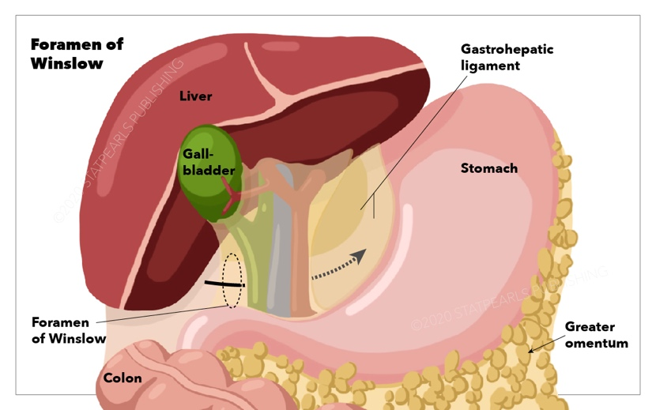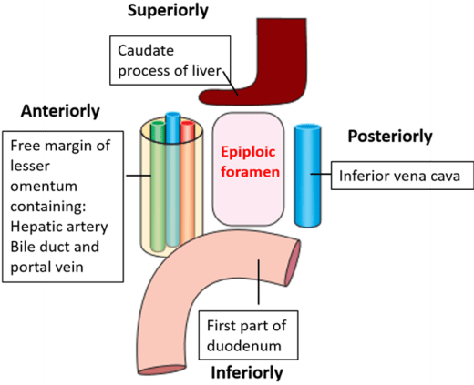

The epiploic foramen is the site at which the greater and lesser sacs of the peritoneal cavity communicate with each other.

Boundaries:

Anteriorly – the lesser omentum with the common bile duct, portal vein and comman hepatic artery in its free edge

Posteriorly – inferior vena cava

Superiorly – the caudate lobe of the liver

Inferiorly – first part of the duodenum

Medially – lesser sac

Laterally – greater sac

Pringles manouvere: compression of the common hepatic artery in the free edge of the lesser omentum by a carefully placed hand in the epiploic foramen may be a life saving manoeuvre at laparotomy to control bleeding from the liver

Stomach:

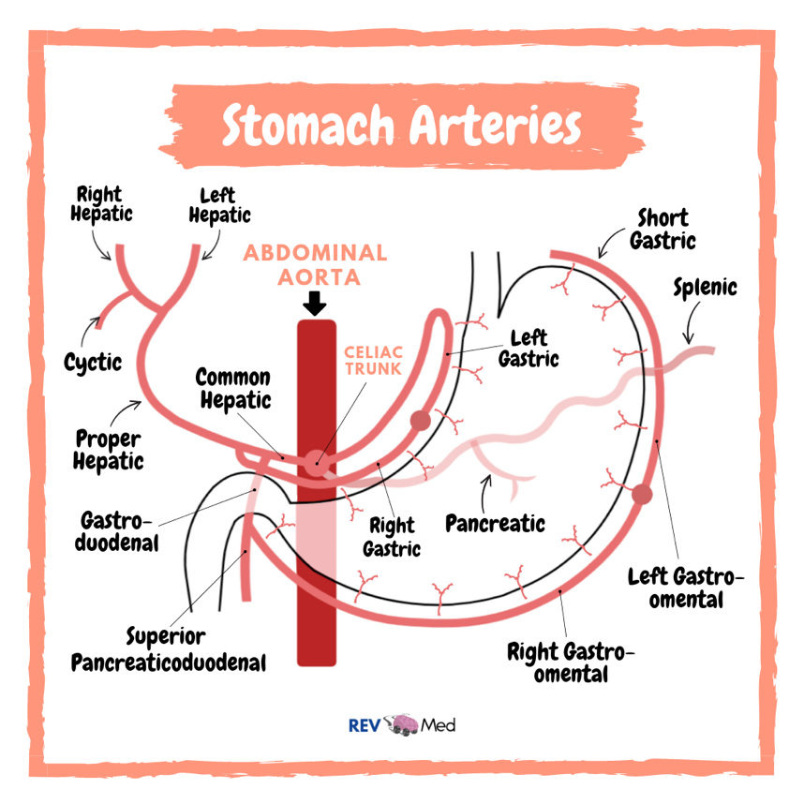

The coeliac trunk divides into 3 main branches. Left hand side.

Left gastric artery

Common Hepatic artery

Splenic artery

Divide the stomach up into 3 main areas – lesser curvature, greater curvature, fundus.

Lesser curvature – supplied by the left and right gastric arteries. The left gastric comes directly off the coeliac trunk. The right gastric is a branch of the hepatic artery.

Greater curvature – supplied by the right and left gastro-epiploic arteries. The right gastro epiploic comes off the gastroduodenal. The gastroduodenal artery arises from the common hepatic artery and lies posterior to the first part of the duodenum. The left gastro-epiploic artery comes off the splenic artery.

Fundus – supplies by short gastric arteries which arise from the splenic artery.

A posterior placed duodenal ulcer may erode through the duodenal wall into the gastroduodenalcausing haemorrhage. A posterior placed gastric ulcer may cause haemorrhage from the splenic artery.

Gallbladder:

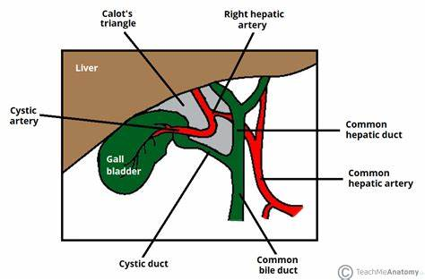

Kehr’s Sign – referred pain from gallstone disease to the right shoulder tip

Courvosier’s Law – in the presence of obstructive jaundice, a palpable gallbladder is unlikely to be due to gallstones

Surface marking of the gallbladder – lies at the angle between the 9th costal cartilage and the lateral margin of the rectus muscle on the right side. Important landmark as it is the site of maximal abdominal tenderness in gallbladder disease.

Calot’s triangle – formed by the liver edge, common hepatic duct and cystic duct. Calot’s triangle reliably contains the cystic artery, the cystic lymph node (of Lund), connective tissue and lymphatics. It is important to dissect out this triangle at laparoscopic cholecystectomy in order to successfully identify and ligate the cystic artery prior to the removal of the gallbladder.

Kehr’s sign – an inflamed of distended gallbladder may irritate the diaphragm which is supplied by the phrenic nerve (c3, c4, c5) – these very same nerve roots also provide sensation to the right shoulder tip by way of the supraclavicular nerves (c3, c4,c5). The body misinterprets the signals that it receives and interprets the pain signals as coming from the right shoulder tip.

Courvosier’s law - in the presence of obstructive jaundice, a palpable gall-bladder is unlikely to be due to gallstones

Cystic artery is usually a branch of the right hepatic.

Spleen:

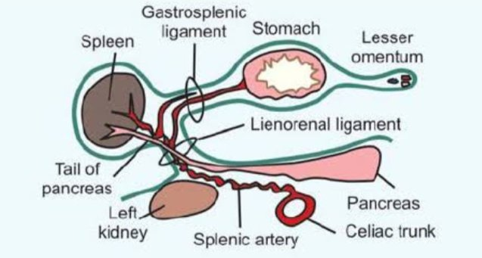

The spleen lies beneath the 9th – 11th ribs on the left side.

Lots of close anatomical relations which can be injured at splenectomy – superiorly is the diaphragm, inferior is the splenic flexure of the colon, posterior is the left kidney, anterior is the stomach and at the hilum is the tail of pancreas and the splenic vessels.

2 ligaments, the gastrosplenic and splenorenal ligaments, connect the hilum of the spleen to the greater curvature of the stomach and the anterior surface of the left kidney.

Gastrosplenic ligament – short gastric and left gastro-epiploic vessels run in the gastrosplenic ligament

Splenorenal ligament – splenic vessels and pancreatic tail lie in the splenorenal ligament

During a splenectomy, the organs that can be damaged are: tail of pancreas, diaphragm, left kidney, splenic flexure of colon.

Appendix:

Blood supply is from the appendicular artery, which is a branch of the ileo-colic artery which arises from the superior mesenteric artery.

Surface landmark of the base of the appendix is situated 1/3 of the way up the line joining the anterior superior iliac spine ot the umbilicus (mcburneys point).

Layers encountered by a surgeon when performing an appendicectomy: Skin, camper’s fascia, scarpa’s fascia, external oblique aponeurosis, internal oblique, transversus abdominis, transveralis fascia, per peritoneal fat, parietal peritoneum

Peri-umbilical pain – afferent nerve fibers concernced with the conduction of visceral pain from the appendix accompany the sympathetic nerves and enter the spinal cord at the level of T10. Consequently, the appendix refers visceral pain to the T10 dermatome which lies at the level of the umbilicus. Only later, when the parietal peritoneum overlying the appendix becomes inflamed, does the pain become more intense and localise to the RIF in the region of McBurneys point.

Taeniae coli are 3 bands of longitudinal muscle on the surface of the large intestine. The base of the appendix is around 2.5cm below the ileocaecal valve where the taenia converge. The tip of the appendix varies.

The appendix is very variable in position. Most commonly lies retrocaecal (75%)

Small Intestine:

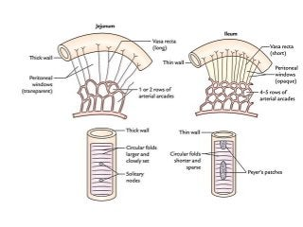

Duodenum has 4 parts which form a C shape around the head of the pancreas. The common bile duct enters the posteromedial wall of the 2nd part of the duodenum at the ampulla of Vater.

Jejunal difference to the ileum:

jejnum has thicker walls than the ileum as the valvulae conniventaes (mucosal folds in the small bowel) are thicker

jejunum has 1 or 2 arcades formed by the mesenteric vessels; the ileum has 4 to 5 arcades

Jejunum has a thinner mesentery with less fat and longer vasa recta

Jejunum as a greater diameter

More prominent peyer patches (aggregated lymphoid follicles) in the ileum

Inguinal Canal:

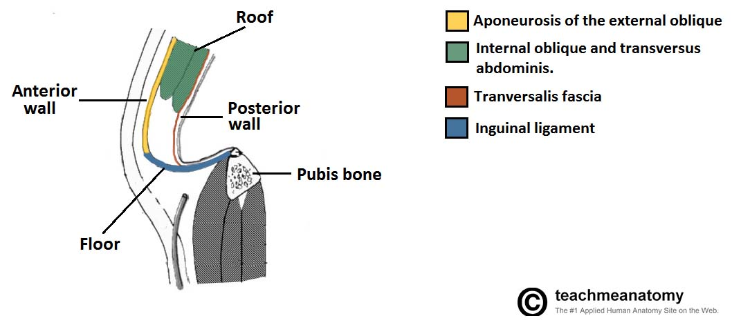

The inguinal canal run between the deep and superficial inguinal rings.

It transmits the spermatic cord in males and the round ligament of the uterus in females.

Deep inguinal ring – 1.5cm above the inguinal ligament, midway between the ASIS and the pubic tubercle (mid inguinal point)

The superficial inguinal ring is an opening in the external oblique aponeurisis and is anterior to the pubic tubercle.

Boundaries –

Anterior – external oblique and internal oblique for lateral 1/3

Posterior – transversalis fasica, conjoint tendon and pectineal ligament medially

Floor – ingunal ligament

Roof – arching fibres of internal oblique and transversus abdominis

Spermatic Cord:

Hesselbach’s Triangle:

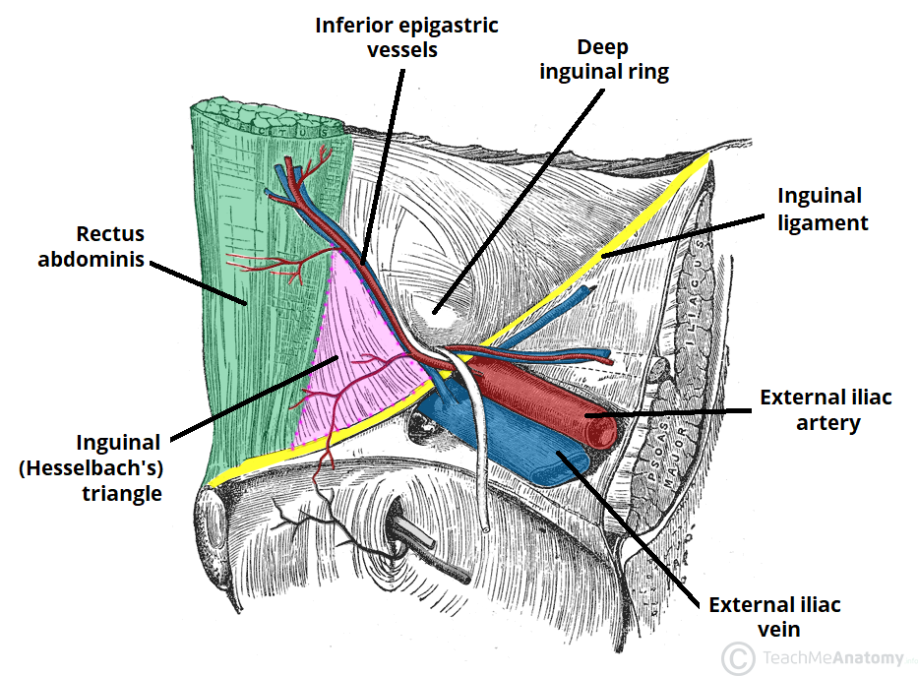

Inguinal hernia lies above and medial to the pubic tubercle.

Direct hernia passes through a weakness in the anterior abdominal wall and passes through the superficial ring only.

Indirect hernia passes through both the deep and superficial inguinal rings and thereby passes along the entire length of the inguinal canal.

Can be distinguished clinically by placing a hand over the deep ring and asking the patient to cough – an indirect hernia is controlled at the deep ring but a direct hernia is not.

The Hesselbach’s triangle is Important as it is an area of potential weakness in the anterior abdominal wall as it is not reinforced by the conjoint tendon. Responsible for causing direct inguinal hernias.

Boundaries –

Inferior – inguinal ligament

Medial – lateral border of rectus abdominis

Lateral – inferior epigastric artery

Neck of an indirect inguinal hernia lies lateral to the inferior epigastric artery, whereas the neck of a direct inguinal hernia lies medial to the inferior epigastric artery.

Femoral Canal:

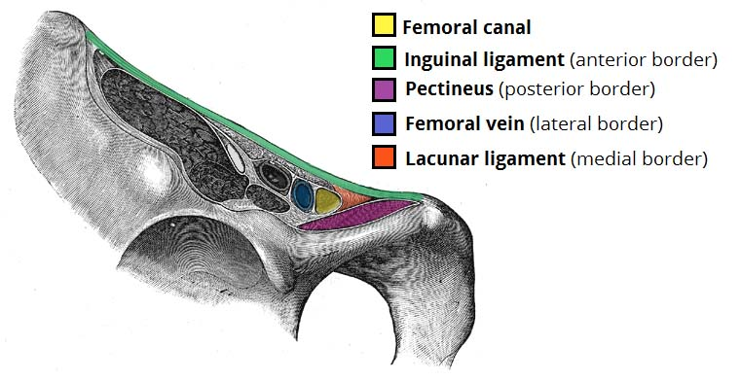

Femoral hernia lies below and lateral to the pubic tubercle

The femoral sheath is divided by 2 partitions that stretch between its anterior and posterior walls. The lateral compartment contains the femoral artery, and the intermediate compartment contains the femoral vein. The medial compartment is the femoral canal.

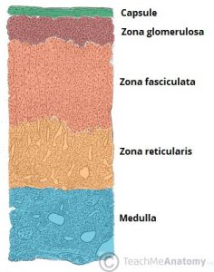Adrenal Gland:

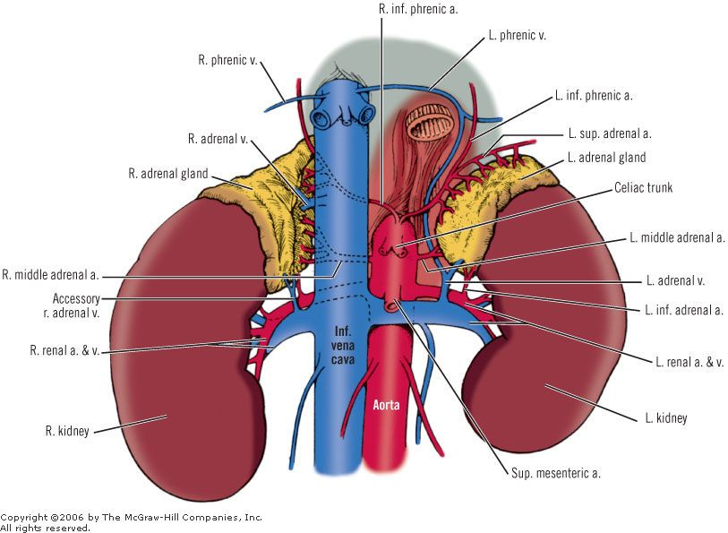

Adrenal glands lie antero-superior to the upper part of each kidney. Lie within their own compartment of the Gerota’s fasica hence why they aren’t always seen or removed in a nephrectomy.

Blood supply – 3 arteries (direct branch from aorta, branch of the renal artery and a branch of the inferior phrenic artery).

Venous drainage – the single main suprarenal vein drains into the nearest available vessel – on the right it drains into the IVC, on the left it drains directly into the renal vein.

Layers of the adrenal gland – Outer cortex and an inner medulla.

Medulla secretes adrenaline and noradrenaline.

Cortex –

G – zona glomerulosa (secretes mineralocorticoids such as aldosterone)

F – zone fasciculata (secretes corticosteroids such as cortisol and small amount of androgens)

R – zona reticularis (secretes androgens and a small amount of corticosteroids)

Scrotum/Testes:

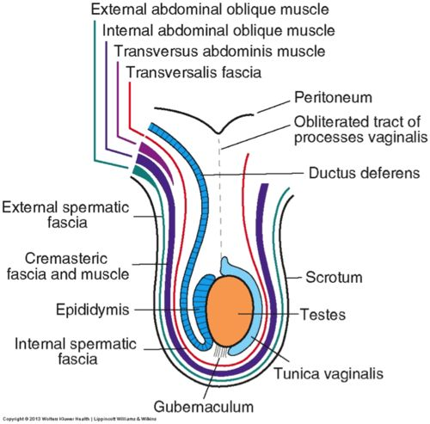

Blood supply – testicular artery which arises directly from the descending abdominal aorta at L2.

Venous drainage – on the right side, the testis drains by way of the pampniform plexus into the inferior vena cava, but the left testis drains into the left renal vein.

A varicocoele should trigger investigation of the left kidney.

Lymphatic drainage – testis drains to the para aortic set of lymph nodes. Scrotum drains to the inguinal group of lymph nodes.

If doing an orchidectomy then you should go through the inguinal approach not the skin so as not to seed.

Some damn Englishman called it the testes

Skin, dartos, external spermatic fascia (from external oblique), cremasteric muscle and fascia (from internal oblique), internal spermatic fascia (from transversialis fascia), tunica vaginalis, tunica albuginea, testis.

Assessment -- can you get above the swelling (if no -> varicocele, indirect inguinal hernia); is the swelling palpable separately from the testis (if no -> testicular tumour, hydrocoele); is the swelling transilluminant (if yes -> hydrocoele), is the swelling painful (if dull ache -> tumour, varicocele, inguinoscrotal hernia, if acute pain -> torsion, epididymo-orchitis).

Hydrocoele – collection of fluid between the parietal and visceral layers of the tunica vaginalis.

Varicocoele – dilation of the veins in the pampiniform plexus

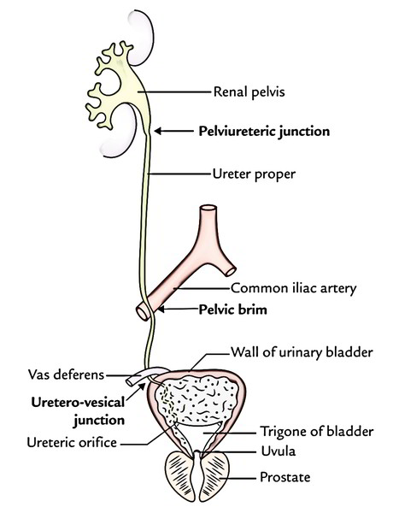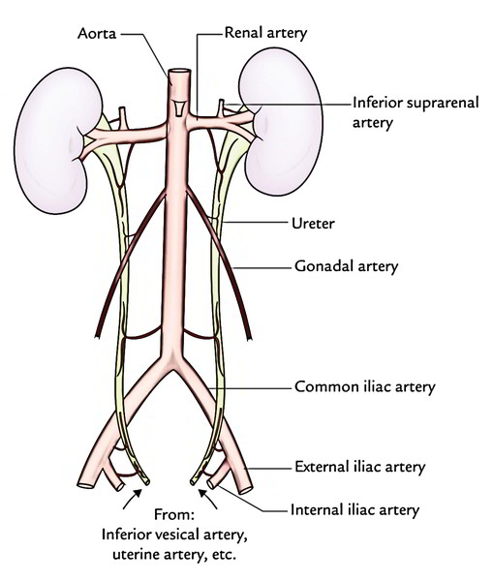Ureters:

Ureters are 25cm long and composed of smooth muscle throughout their entire length. Lines by transitional epithelium.

Blood supply: the blood supply is similar to that of the oesophagus, in that it is segmental.

Upper third – renal arteries

Middle third – branches given off the descending abdominal aorta

Lower third – superior and inferior vesical arteries

The middle third of the ureter has the most tenuous blood supply and so its most vulnerable to post op ischeamia and stricture formation.

Three places that are narrowings and often form the site of obstruction in ureteric calculus disease

* Pelvi ureteric junction
* Where the ureter crosses the pelvic brim in the region of the bifurcation of the common iliac artery
* Vesico-ureteric junction

VUJ is the narrowest.

Rectum:

Blood supply – superior rectal (from inferior mesenteric),middle rectal (from internal iliac) and inferior rectal (from internal pudendal) arteries.

Portosystemic anastomosis in the lower rectal and upper anal canal walls, as branches of the superior rectal (portal) and inferior/middle rectal veins (systemic) meet in the external and internal venous plexuses.

Abdomen Arterial Supply:



GI Anatomy Key Points

* + Renal veins drain directly into IVC
  + Head of pancreas lies in transpyloric plane and is anterior to left kidney
    - Transverse mesocolon attached to head/neck/body of pancreas
    - Uncinate process lies posterior to SMA
    - IMA passes behind body of pancreas
  + Uncinated process lies between aorta and SMA
  + Gonadal arteries arise at L2 from aorta
  + Portal vein lies in free right edge of lesser omentum behind the neck of pancreas, CBD and hepatic artery 🡪 control haemorrhage by pringles manoeuvre
    - Normal portal vein pressure = 5-10 mmHg
    - Portal + systemic circulation = lower oesophagus/distal rectum/anterior abdominal wall
      * Management of varices is endoscopic
      * Varicies bleed from superficial oesophageal veins
  + Inferior border of inguinal canal is the inguinal ligament
  + Gallbladder blood supply from coeliac artery (T12)
    - Coeliac 🡪 left gastric + splenic + common hepatic
    - Right hepatic artery gives of cystic artery
  + Aorta
    - Crossed by left renal vein inferior to SMA – left renal vein crosses IN FRONT of aorta
    - Gonadal arteries given off between SMA and IMA
    - Inferior phrenic arteries are first branch
  + Coeliac
    - Branches = splenic, common hepatic, left gastric
  + SMA L1
    - Supplies midgut
    - Third part of duodenum is posterior to it
    - Origin lies behind neck of pancreas
    - Posterior to splenic vein
  + IMA L3
    - Supplies hindgut
  + Lesser omentum
    - Encloses right gastric vessels
    - Supplied by right and left gastric arteries
    - Attached to first part of duodenum and ligamentum venosum
  + Transverse mesocolon attached to head, neck, body of pancreas
  + Terminal ileum – absorption of Vit D and Vit K and bile salts
  + Jejunum – absorbs calcium and folic acid
  + Gerotas fascia surrounds kidney and found posterior to colon
  + CBD lies to right of hepatic artery in lesser omentum
  + Lienorenal ligament connects spleen and left kidney and contains splenic artery and vein
  + Short gastric arteries are branches of splenic and are found in gastrosplenic ligament
  + Hepatic H
    - Gallbladder, IVC, ligamentum teres, porta hepatis
  + Linea semilunaris
    - Crossed by inferior epigastric vessels
    - Marks lateral rectal sheath
    - Forms medial border of hesselbachs triangle (lateral border is inferior epigastric vessels and inferior border is inguinal ligament)
  + Pancreaticoduodenal arteries
    - Superior – from gastroduodenal (from coeliac)
    - Inferior – from SMA
  + Left colic flexure stops spleen from moving downwards
  + Ligament of Treitz – muscle derived from right crus
    - Suspends fourth part of duodenum from posterior abdominal wall
  + IVC starts at L5, lies to right of aorta and posterior to third part of duodenum
    - Right renal artery passes posterior to IVC
    - Forms posterior wall of epiploic foramen (free edge of lesser omentum forms anterior border)
  + Portal vein is most posterior in porta hepatis
  + Chief cell = pepsinogen; parietal cell = intrinsic factor and gastric acid
  + Right suprarenal gland touches bare area of liver
  + Inferior epigastric vessels lie between transversus abdominis and peritoneum
  + Kidney directly related to psoas muscle
  + Uterine arteries anastomose with ovarian artery
  + Femoral artery is anterior to vein in adductor canal
    - Vein lies medial to artery as it exits canal
  + Anterior relations of lesser sac are:
    - Visceral peritoneum along posterior stomach
    - Lesser omentum
    - Gastrocolic omentum
  + First part of duodenum forms inferior border of epiploic foramen
    - Superior border is caudate lobe

GI Conditions

* Pancreatitis
  + MOSF scale used in pancreatitis
  + APACHE 2 scale
  + BALTHAZAR – CT based scoring system
  + GLASGOW SCORE
    - Age > 55
    - Glucose > 10
    - WCC >15.5
    - LDH > 600 (or AST >200)
    - Calcium < 2
    - Urea > 16
    - PaO2 < 8
    - Albumin < 32
      * Mortality 0-2 (5%), 3-4 (20%), 5-6 (40%), 7-8 (100%)
* GI pathology
  + Pseudomembranous colitis – c diffe, necrotic epithelial cells + fibrin and neutrophils
  + FAP – villous adenomas
  + Achalasia
    - Dysphagia to solids and liquids together
      * Cancer is progressive
    - Tx = lifestyle modification, nifedipine (reduce LOS pressure), balloon dilatation
  + Liver cancer
    - Rf = alcoholic liver disease, Hepatitis
    - Poor survival, surgical only option
  + VIP – vasodilation of GI resistance vessels, relaxation of enteric smooth muscle, inhibit gastric acid secretion, stimulates pancreatic juice secretion
  + Mesenteric infarction
    - Produces plum coloured stool
    - Metabolic acidosis
    - Requires excision of ischaemia gut
  + 20% triglyceride digestion due to lingual lipase
  + Bilirubin carried to liver bound to albumin and conjugated to make it water soluble
    - At distal ileum, bilirubin converted to urobilinogen or excreted in faeces as stercobilinogen or reabsorbed
  + S cells in duodenum screte secretin
  + Meckels arises on anti-mesenteric border of small bowel
* Kidney
  + Right renal vein lies anterior to right renal artery and ureter is posterior
* Gallstones
  + 15% can be seen on XR
  + Porcelain gallbladder = chronic cholecystitis 🡪 risk of gallbladder cancer
    - Aschoff-Rokitansky sinuses linked to chronic cholecystitis
  + Pain linked to CCK release – causes contractions and sphincter release
* Ulcerative colitis
  + Linked to PSC – inflammation/fibrosis/strictures of intra+extrahepatic bile ducts 🡪 beady appearance
  + Goblet cell depletion and crypt abscess, **pseudopolyps** (inflammatory)
* Nutrition
  + TPN in liver failure – avoid emulsions/fatty acids
  + 25-35kcal per kg per day
* Anal fistulas
  + Can be high or low
    - Low is common, high is rare
    - High 🡪 cancer, tb, crohns, UC, diverticular disease
* Crohns
  + Cholesterol gallstones as bile salts not absorbed so can’t digest cholesterol
* Pseudo-obstruction – ineffective peristalsis
  + RF = elderly, immobilised, cerebral palsy, Parkinsons
  + Recurrent bowel obstruction with no anatomical abnormality
  + Tx – can be improved by colonoscopy
* Rehydration – use sodium chloride
* Colon cancer
  + Do colonoscopy with biopsies (CT colonoscopy if can’t tolerate)
  + Dukes
    - A – muscular propria
    - B – beyond muscular propria
    - C – lymph node involvement
    - D – mets
* Haemorrhoids
  + First degree – dietary advice (band ligation if not resolving)
  + If thrombosed/strangulated – analgesia, bedrest, elevate legs, surgery
* Orlistat – lipase inhibitor – prevent fat breakdown
* Atrophic gastritis
  + Megaloblastic anaemia
    - Hypersegmented neutrophils, high MCV, megaloblasts in bone marrow
* High reticulocyte count = haemolytic anaemia
* Zollinger-Ellison syndrome – multiple peptic ulcers linked to gastrinoma
  + Gastrin promotes excessive acid secretion causing ulceration and diarrhoea
* Deficiencies
  + Gastric resection – risk of iron and Vit b12 deficiency
  + Fat soluble vitamins – can’t be absorbed if no bile salts so at risk in terminal ileum resection
* Whipples
  + Infection – tropheryma whipplei
  + Steatorrhoea and weight loss and arthritis
  + Biopsy shows PAS positive marcophages
* Liver disease
  + Child Pugh
    - A – albumin, ascities
    - B – bilirubin
    - C – confusion (encephalopathy)
    - P- prothrombin
* Duodenal ulcer
  + Pain on waking in the middle of the night
  + Pain 2hrs after food
* Tetralogy of fallot linked to exomphalos and bladder exstrophy
* Hernias
  + Inguinal – Lichtenstein procedure = mesh fixed to reflected edge of inguinal ligament
    - Can be repaired under anaesthetic block of T12-L1 (ilioinguinal and iliohypogastric)
* Zinc required for RNA and DNA synthesis
* Vit C deficiency increases risk of wound dehiscence
* Embryology
  + Midgut rotates 270’ around SMA anticlokcwise
  + Hindgut moves to the left on hinge of its mesocolon
* Mayo repair used for umbilical hernia
* Gastrin stimulates gastric acid secretion
  + Somatostatin inhibits gastric acid release
* PTH levels fall in hypomagnesaemia
* Raised AST and ALP suggests mixed hepatic and cholestatic damage (aka acute alcoholic hepatitis on a background of chronic liver disease)
  + Mild macrocytosis
  + Raised GGT
* Toxic megacolon
  + Colonic dilatation of >6cm
  + Loss of haustra and thumbprinting
  + Tx = resus, abx, NG tube
  + Can be caused by c differ (reulsting in perforation)
* Anal fistulas
  + Caused by anorectal abscess/trauma/TB/crohns
* Biliary atresia
  + Jaundice, pale stools, dark urine, hepatosplenomegaly, ABSENT GALLBLADDER – no diagnosis test
  + Tx = kasai procedure
* Haemolytic disease of newborn – non-obstructing jaundice so normal urine and stools
* Scleroderma – anti-centromere antibodies
  + CREST syndrome
* Dumping syndrome
  + In patients with intestinal short circuits
  + Early dumping – hypovolaemia – 45 mins
  + Late dumping – hypoglycaemia – 4 hrs
* Intussusception most commonly affetcs ileum entering caecum/Meckels/hyper plastic peyers patch
  + Seen on USS
* Haemangiomas are most common benign tumour of liver
* Salivary flow increases with nausea
  + Normally produce 1.5 litres saliva per day
* Parastomal hernias
  + 10% of colostomies
  + Asymptomatic
* Internal iliac artery
  + Posterior
    - Superior gluteal artery (gluteus medius and minimus)
  + Anterior
    - Inferior gluteal artery (gluteus maximus)
* External iliac artery
  + Common femoral artery 🡪 superficial femoral artery and profunda femoris
* Leriche triad = impotence, buttock claudication and weak femoral pulses
  + Common iliac artery disease
* Pilonidal abscess
  + Incision and drainage
  + Abx if infection or surrounding cellulitis

* Abscess
  + Ischiorectal – bordered by levator ani, anal canal, skin, ischial tuberosity
  + Horseshoe – ischiorectal that extends to both sides
  + Intersphincteric – between internal and external sphincters (not visible) - EUA required for diagnosis
  + Perianal – superficial
  + Supralevator – above levator ani (can be caused by intra-abdominal inflammation)
* Small bowel atresia
  + Bilious vomiting, abdo distension, failure to pass stools after meconium
  + XR = distended small bowel loops with fluid levels
* Hep C – 70% will develop chronic hep c
* Alcoholic liver disease can cause mestrusral disturbance
* Gallstones is commonest cause of obstructive jaundice in UK
* Erythema ab igne
  + Chronic pancreatitis – epigastric pain, steatorrhoea, polyuria
    - Linked to alcoholic excess
* Ascities
  + Exudate – low gradient; malignancy, pancreatitis
  + Transudate – high gradient; liver disease, failure
  + Straw fluid = malignancy/cirrhosis/failure
  + Chylous = obstruction of lymphatic duct
  + Haemorrhage = pancreatitis
* HNPCC – colon and ovarian tumours
  + Mucinous, signet ring
* Landmark for superficial inguinal ring = intercrural fibres
  + 1cm above and lateral to pubic tubercle
* Barrets – metaplasia from squamous to COLUMNAR
  + Tx = ppi
* aNAL CANCER
  + linked to HPV
  + raio and chemo (5-FU + mtomycin
* Detectable jaundice at 30
* GORD can cause oesophageal structuring
* Urea breath test is most sensitive for h pylori
* Appendicitis
  + Scoring = Alvarado
    - <5 = unlikely
    - >7 = predictive
* Gilberts syndrome
  + Absence of bilirubin in urine
* Hepatorenal space
  + Between right lobe of liver and right kidney
  + Communicates with lesser sac, right paracolic gutter and right subphrenic space
* Hernia
  + Sliding hernia – symptoms of GORD
  + Rolling hernia – gastric strangulation, necrosis, gangrene
* Linitis plastica – thick stomach with reduced distensibility
  + Invasion of all layers diffusely
  + Signet rings
* Pancreatitis
  + Hypocalcaemia is common – caused by fat saponification
  + Pseudocysts develop in lesser sac
* Leiomyoma is most common benign oesophageal tumour
* Gastroschisis – no sac, just abdominal contents
* FAP – ophthalmology or DNA screening
  + Congenital hypertrophy of retinal pigment epithelium
* Ileum – peyers patches
* Inferior mesenteric vein drains upper rectum
* UC and PSC – increased risk of cancer
* Mid-inguinal point = femoral pulse
  + ASIS to pubic symphysis
* Midpoint of inguinal ligament = deep inguinal ring
  + ASIS to pubic tubercle
* Peutz-Jeghers polyps are usually in small bowel
* Upper GI bleed
  + Blatchford – risk of requiring intervention
  + Rockall – predict risk of rebleeding
* Fat emulsified at proximal small intestine
* Risk of cancer is higher in UC
* Adenocarcinoma in lower oesophagus
* SCC in upper oesophagus
* Lesser sac communicates with general peritoneal cavity via epiploic foramen
* Vagal nerve stimulation causes gastric acid release
* Crohns
  + More likely to get cholesterol gallstones and calcium oxalate kidney stones
* Anal fissures
  + First line management is 2% diltiazem ointment
* Segmentation mixes chime with mucus
* Peristalsis moves chime along intestine
  + Created by automatic depolarisation by bowel wall cells
* 80% colorectal cancer arises from polyps
* Prostate cancer metastasises through internal vertebral venous plexus
* In nephrectomy, subcostal neurovascular bundle is protected because it lies in costal groove
* Gastric emptying proportional to volume of stomach content and composition
* Rectal prolapse in children resolve with conservative treatment
* Sickle cell crisis
  + Chronic haemolytic anaemia and can cause abdominal pain
* Colostomy complications
  + Fistulas can occur following reversal due to anastomotic leakage
    - **Fistulas more likely to heal spontaneously if no distal obstruction**
* Pancreatic pseudocyst
  + Treat with elective cystogastrostomy/radiologically (drainage)
* Fistulas
  + Types
    - Enterocutaneous (intestines to skin)
      * High or low output
    - Enteroenteic/enterocolic
      * Intestines
    - Enterovaginal
    - Enterovesicular
      * To bladder – cause UTI
  + Management
    - Will heal spontaneously if no distal obstruction/underlying IBD
    - May require TPN and octreotide if high fistula (ie duodenal) and high output and losing electrolytes
* Anal fistulas
  + Assess via USS/MRI if needed
  + Treatment
    - Seton suture – allows drainage of sepsis – treatment in IBD fistulas
      * Simple – encourage drainage and fibrosis
      * Cutting – re-tightened and cuts skin
    - Fistulotomy – if low and simple and acute sepsis resolved
* Hernias
  + Spigelian – between internal and external oblique, lateral to rectus abdominis 🡪 open/laparoscopic repair
  + Lumbar – through lumbar triangle 🡪 direct repair +/- mesh
  + Obturator – through obturator canal 🡪 when acute, requires laparotomy
  + Richters – wall of small bowel strangulated within a hernia
  + Incisional – minimise via Jenkins rule
  + Bochdalek – congenital diaphragmatic hernia, occurring mostly on left side, can be large and result in scaphoid abdomen and absent apex beat
  + Morgagni – rare, herniation through foramen of Morgagni; right sided
  + Umbilical – majority resolve by aged 2 so surgery performed after 3rd birthday
  + Paraunbilical hernia – repaired via Mayos technique
  + Littres – hernia containing meckels
* Upper GI bleed
  + Give terlipressin in varices then band during endoscopy
    - If can’t band due to severe bleeding, pass Sengaksten Blakemore tube
  + Surgery – underrunning of ulcer if continuing bleeding despite initial treatments
* If suspect IBS, do faecal calprotectin to rule out IBD
* Barrets surveillance – do quadrantic biopsies 6 monthly
* Nocturnal diarrhoea and incontinence suggest IBD
* In emergency surgery, tumours above peritoneal region require loop ileostomy. Tumours below peritoneum (ie low anal tumours) require loop coleostomy
* ?injury post ERCP requires CT scan
* Obstruction secondary to cancer – to laparotomy, sided resection and anastomosis (don’t need a stoma as can anastomse straight away)
* Pancreatic necrosis
  + Assess with FNA then do necrosectomy
* Repair femoral hernias urgently
* Oesophageal SCC 🡪 do combined chemoradiotherapy